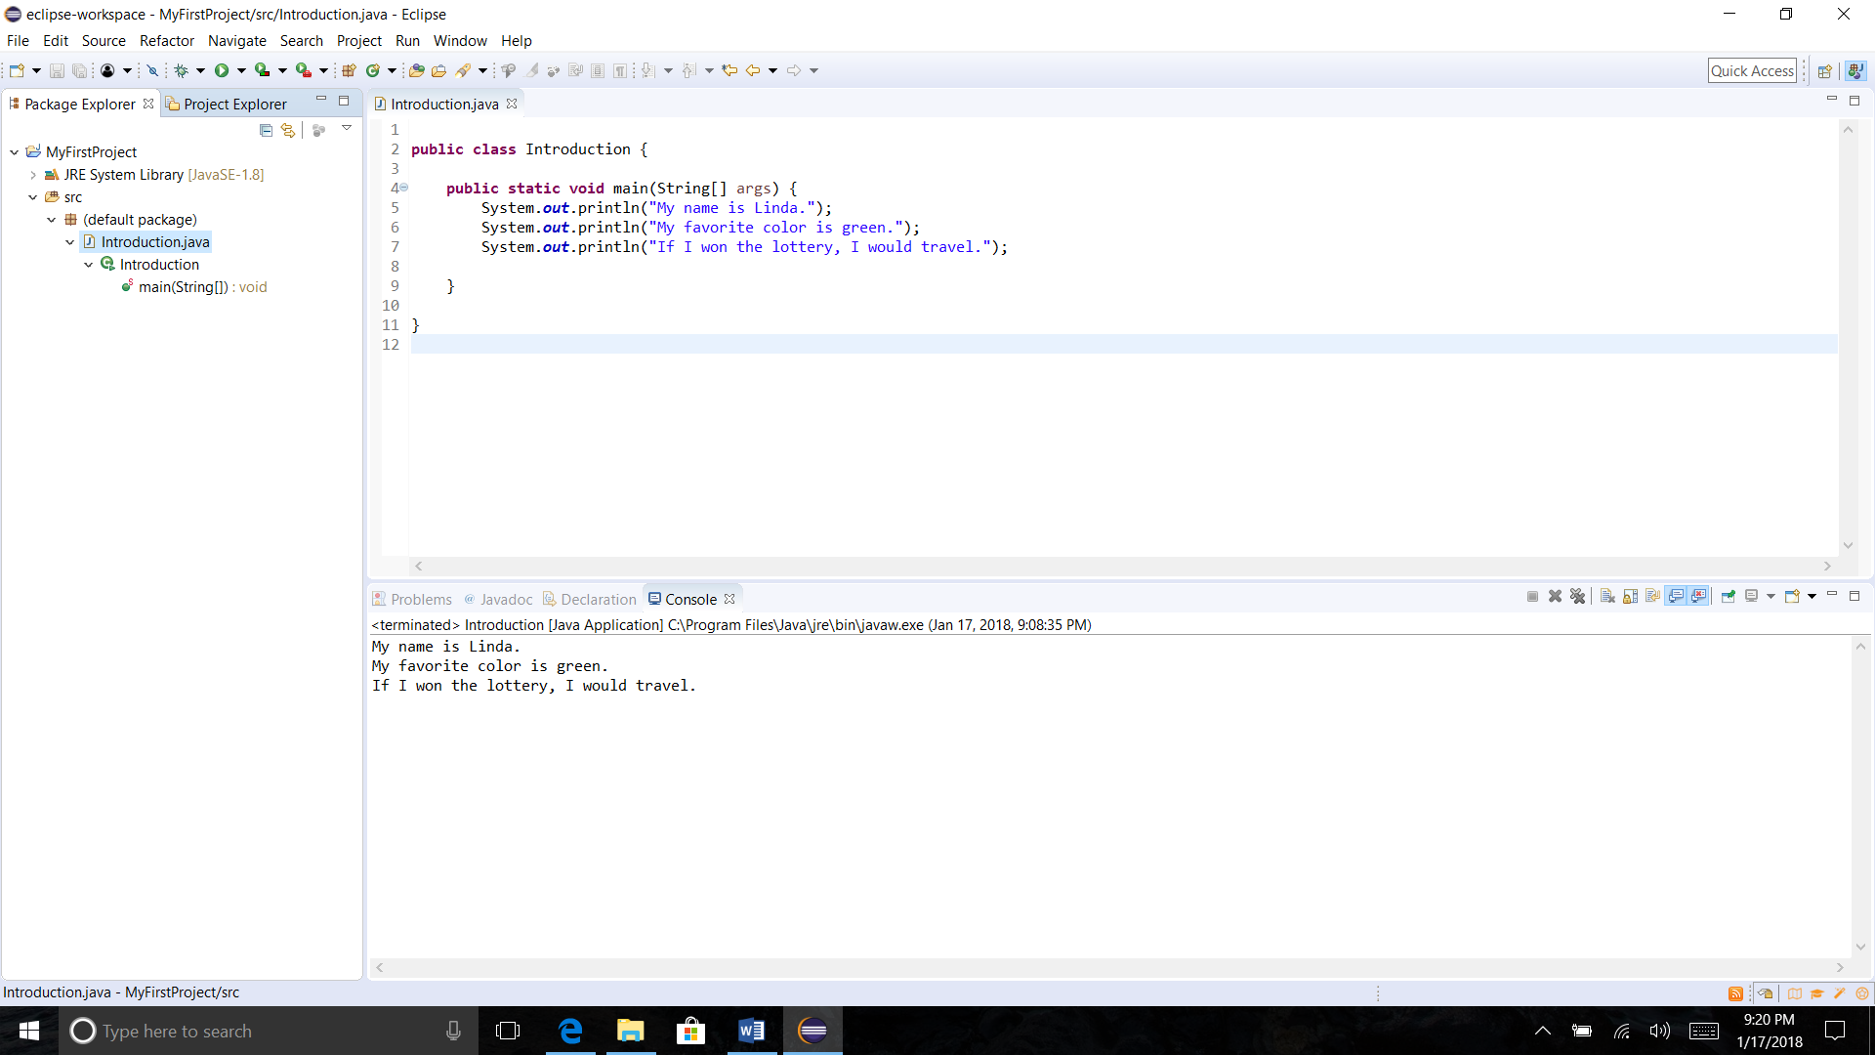
CST-105 Second Part to Exercise 1

